Central
Delta-Mendota Groundwater sustainability
Agency

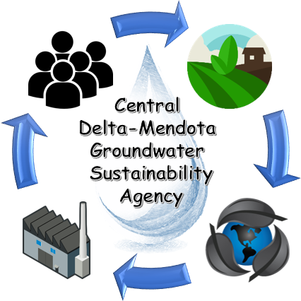

Eagle Field WD Fresno County Fresno Slough WD Merced County Mercy Springs WD Oro Loma WD Pacheco WD Panoche WD San Luis WD Santa Nella County WD Tanquillity ID Widren WD

Groundwater Well Registration Form (Side A)
All landowners/residents who own a Domestic Well, Monitoring Well, or Production Well, whether operational or not, are required to completely fill out both sides of this registration form. Any form submitted with incorrect or missing information will be considered incomplete and may result in penalties if not corrected before the registration deadline. Well information that was received from participating well owners during the 2020 Well Census has already been included in the to the Central Delta-Mendota Groundwater Sustainability Agency (“CDMGSA”) registration report. Attached with this form is the complete list of registered wells, if your well is not on this list, please fill out both sides of this form and return to CDMGSA via email (kliddy@hgcpm.com) or by mail at 12931 S Hwy 33, Santa Nella, CA 95322.

If you have any questions or require assistance in filling out your form, please contact Karlee Liddy at (916)767-4287 or email kliddy@hgcpm.com.

The CDMGSA encourages well owners to submit their forms early and requires all wells to be registered no later than June 1, 2026. Failure to submit a completed form by June 1, 2026, or within 30 days of the date of the well completion report for any wells constructed after June 1, 2026, will result in fines as outlined in Exhibit A of the Well Census and Registration Policy.

Landowner / Resident Name: _____________________________________________________
Address: ______________________________________________________________________

Contact information, please check the box to indicate preferred method of contact:
□ Phone:____________________________________
□ E-mail: ___________________________________

Signature ___________________________________________________Date______________

Groundwater Well Registration Form (Side B)
Central Delta-Mendota Groundwater Sustainability Agency

Instructions:
For each groundwater well, the owner must provide the parcel number, latitude and longitude, and well type. Location of the well can be provided using the latitude and longitude from a web browser tool such as Google Earth, Google Maps, Bing Maps etc. You may also attach a screenshot of the map with the well location, if helpful. Latitude and longitude may be reported in either Decimal degrees or Degrees, Minutes’, Seconds” (see examples below).
For well type, see the CDMGSA’s Administrative Policy Number 1 for definitions on well types and indicate the appropriate well type. For domestic well owners, to register a well as de-minimis, the owner must submit the well completion report with this form. Additional information may be requested to make the de-minimis determination.

Well List | Parcel Number (APN) | County | Latitude | Longitude | Well type (de-minimis, domestic well, production well, monitoring well)
Example | 088-002-033 | Merced | 37.262962 | -121.003786 | De-minimis
Example | 088-002-034 | Merced | 37 88’ 77” | -121 22’ 33” | Production
1
2
3
4
5
6
7
8
9
10
11
12
13
14
15

Use additional sheets if necessary

If you have any questions or require assistance in filling out your form, please contact Karlee Liddy at (916)767-4287 or email kliddy@hgcpm.com.

